

Job Title: User Researcher
Location: Remote, Sheffield, Bristol, Manchester, London
Contract type: Fixed term contract – ending April 2028
Accountable to: Audience Insight and Research Manager
Salary: Shelter Grade 4
Hours: 35 per week (pro-rata if part time)
Leave: 30 days holiday per annum plus bank holidays

About Shelter

A home is a fundamental human need, as essential as education or healthcare. Yet millions of people across Britain struggle on a daily basis with homelessness, bad housing conditions, soaring rents, discrimination, and the threat of eviction.

Above all we seek a transformation in housing policy, including investment in homes people on low incomes can actually afford – an investment that has been missing for decades and from all political parties, so that now the human cost has become intolerable.

We need ambitious, best-in-class individuals who are passionate about our cause to join us at this exciting time. This is your chance to play a part in the fundamental change we are striving to achieve.

Why join Shelter?

We welcome anyone to apply who possess the qualities and behaviours outlined or who believes they have the propensity to learn them fast. You will be joining an inclusive and supportive team who welcome people from all backgrounds. What’s important isn’t your level of education or the opportunities which you have had, it’s about you and how you seize the opportunities ahead of you.

We are happy to talk about flexible working, personal growth, and to promote a workplace where you can be yourself and achieve success based only on your merit. We also offer the following benefits:

- Flexible working hours
- Flexible working practices
- 30 days paid holiday plus bank holidays
- Competitive pension scheme
- Salary sacrifice schemes

Diversity Statement
At Shelter we are united by our purpose to defend the right to a safe home; our enemy is the social injustice at the core of the escalating housing emergency. We believe to win that fight; we must be representative of the people we are here to help and those who support our movement for change. In all our people decisions, we take pride in being inclusive, fair, equitable and transparent.

We have committed to combat racism both within and outside Shelter and welcome you on our journey to becoming a truly anti-racist organisation.
About the team
This role sits in the 7-person Strategic Insight and Evaluation team which sits under in the Digital and Audience Engagement sub directorate, within the Campaigns, Policy and Communications (CPC) department.
The team is a keystone in shaping and delivering the work of Shelter and brings together strategic audience insight and user research and monitoring, evaluation and learning.
The team has a primary mandate to deliver a full range of integrated strategic support across Shelter to ensure the delivery of coherent, high quality, highly strategic public engagement approaches. It’s a central point in ensuring that all work to deliver Shelter’s strategy is planned using best practice principles of programme design, monitoring, evaluation and learning and is underpinned by user research and audience insight.
Within the Strategic Insight and Evaluation team, the Audience Research and Insight function advocates for and demonstrates the value of being audience centered and insight led in our digital discovery design, and project and campaign development. The research and insight team allows Shelter to create engaging experiences which harness and amplify people power in the fight for home.
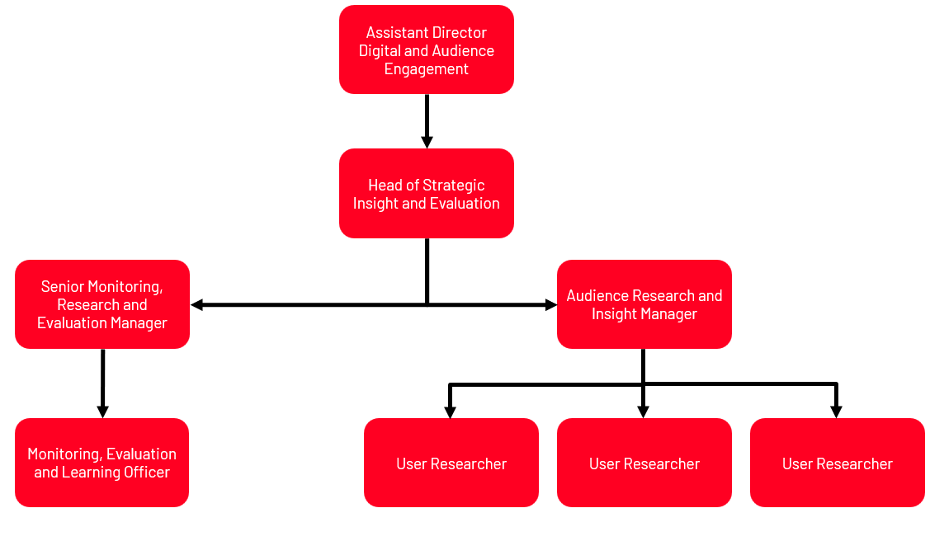

About the role

The User Researchers play an integral role in delivering Shelter’s Digital Purpose:

Digital enables Shelter to meet its goals by creating engaging experiences which harness and amplify people power in the fight for home.
Working closely with the digital product teams you will use an iterative and user-centred approach to plan, design and facilitate research activities with users to help teams get a richer understanding of the people that are engaging with Shelter’s digital products and services so that we can design solutions to meet their needs or goals. These users could be engaging with our services, our income generation or change campaigns, or could be looking for volunteering experiences.
Role Specific Responsibilities

Specific responsibilities of this role include:

- Contributing to good practice user research standards for the organisation, including ethics and safeguarding and supporting the adoption of good practice amongst other researchers and designers.
- Translating digital design problems or opportunities into research questions, developing rigorous research plans, and designing user research activities that are best suited to inform design and decision making within time constraints.
- Actively demonstrating the value of user-centred design with teams not familiar through facilitation and sharing skills and knowledge, ultimately building confidence and helping to embed user centered design practices and the Shelter’s digital purposeto ensure that we continually improve our design practices and processes and advocate for the voice of users.
- Planning, recruiting and facilitating inclusive user research activities, effectively involving your product team along the way, ensuring we have insight that enables us to understand our audiences and their needs most effectively.
- Facilitating analysis and synthesis of qualitative and quantitative data as a collaborative team activity leading teams to clear insights and actionable recommendations.
- Contributing to team planning and help to guide your team effectively through the design process.

About you

You will have:
Essential criteria:
- Experience of using insight to help teams frame a design hypothesis and guide teams to measure success, combining behavioural and experiential insight.
- Ability to plan research activities & recruiting people for inclusive user research.
- Experience of using a variety of user research methods, including usability testing, contextual research, in-depth interviews, surveys, workshops, and desk research.
- Ability to analyse data to document insights and present evidence clearly and effectively to deliver actionable recommendations.
- An understanding of user-centred design and how to balance user needs and strategic objectives
- Strong communication and facilitation skills including the ability to listen to design or project teams, take on feedback, and navigate complex discussions.
- Good prioritisation skills, and the ability to change priorities at short notice.
- Understanding of Agile, Lean, Scrum and product-based approaches and how they relate to design and user research.

Desirable criteria:

- Experience of contributing to the improvement of good research practices.
- Ability to bring a team together to analyse and synthesis qualitative and quantitative data.
- Experience of designing research in an inclusive and accessible way to meet the needs of a diverse audience.

Required behaviours

The Shelter Behaviours demonstrate the attitudes and approaches we take to our work; from how we do things, how we treat each other and expect to be treated both internally and externally. They help us to have the culture we need to deliver our ambitious strategy.
At Shelter we have 5 overall behaviours, that are each made up of 3 descriptors, these are outlined below.
We work together to achieve our shared purpose
- by actively collaborating and putting trust in the people we work with
- by recognising the contribution of others
- by carefully considering the “how” when taking on new projects and initiatives

We prioritise diversity and have an inclusive and open mindset
- by not tolerating and actively tackling racism and any other forms of hate and discrimination
- by creating safe spaces for people to be their authentic self, challenge each other and learn
- by being compassionate towards the people we work with and prioritising each other’s wellbeing

We enable decision making
- by giving people the tools, they need to make well informed decisions
- by being accountable for the decisions we make
- by delegating authority to those closest to the work

We create change and align behind our strategy
- by participating in change initiatives that deliver our strategy
- by supporting tough strategic choices
- by saying no to work that does not serve our purpose

We are open to risk and learning from our experiences
- by learning from our failures and successes
- by being reflective and giving and receiving feedback
- by being proactive and taking initiative

Other information
- All staff should adhere to Shelter's Equality Policy and will be expected to play a key role in its successful implementation.
- This post is not exempt from the Rehabilitation of Offenders Act.

Please note
This job description cannot cover every issue or task that may arise within the post at various times and the post-holder will be expected to carry out other duties from time to time which are broadly consistent with those in this document. This job description does not form part of the contract of employment.

Required behaviours
The Shelter Behaviours demonstrate the attitudes and approaches we take to our work; from how we do things, how we treat each other and expect to be treated both internally and externally. They help us to have the culture we need to deliver our ambitious strategy.

At Shelter we have 5 overall behaviours, that are each made up of 3 descriptors, these are outlined below.
We work together to achieve our shared purpose - essential for this role
- by actively collaborating and putting trust in the people we work with
- by recognising the contribution of others
- by carefully considering the “how” when taking on new projects and initiatives

We prioritise diversity and have an inclusive and open mindset - essential for this role
- by not tolerating and actively tackling racism and any other forms of hate and discrimination
- by creating safe spaces for people to be their authentic self, challenge each other and learn
- by being compassionate towards the people we work with and prioritising each other’s wellbeing

We enable decision making - essential for this role
- by giving people the tools, they need to make well informed decisions
- by being accountable for the decisions we make
- by delegating authority to those closest to the work

We create change and align behind our strategy
- by participating in change initiatives that deliver our strategy
- by supporting tough strategic choices
- by saying no to work that does not serve our purpose

We are open to risk and learning from our experiences
- by learning from our failures and successes
- by being reflective and giving and receiving feedback
- by being proactive and taking initiative

Other information

- All staff should adhere to Shelter's Equality Policy and will be expected to play a key role in its successful implementation.
- This post is not exempt from the Rehabilitation of Offenders Act

Please note :

This job description cannot cover every issue or task that may arise within the post at various times and the post-holder will be expected to carry out other duties from time to time which are broadly consistent with those in this document. This job description does not form part of the contract of employment.

