

Job Description

Job Title: Finance Analyst – Restricted Funds
Location: Hybrid working – expected to travel into London Head Office (EC1V 9HU) at least one day a week.
Contract type: Fixed Term Contract – to 31 March 2027
Accountable to: Senior Finance Business Partner
Salary: £40,605.46 per annum including London Weighting
Hours: 35 per week
Leave: 30 days holiday per annum plus bank holidays

About Shelter

A home is a fundamental human need, as essential as education or healthcare. Yet millions of people across Britain struggle on a daily basis with homelessness, bad housing conditions, soaring rents, discrimination and the threat of eviction.

Above all we seek a transformation in housing policy, including investment in homes people on low incomes can actually afford – an investment that has been missing for decades and from all political parties, so that now the human cost has become intolerable.

We need ambitious, best-in-class individuals who are passionate about our cause to join us at this exciting time. This is your chance to play a part in the fundamental change we are striving to achieve.

Why Join Shelter?

We welcome anyone to apply who possess the qualities and behaviours outlined or who believes they have the propensity to learn them fast. You will be joining an inclusive and supportive team who welcome people from all backgrounds. What’s important isn’t your level of education or the opportunities which you have had, it’s about you and how you seize the opportunities ahead of you.

We are happy to talk about flexible working, personal growth, and to promote a workplace where you can be yourself and achieve success based only on your merit. We also offer the following benefits:
- Flexible working hours
- Flexible working practices
- 30 days paid holiday plus bank holidays
- Competitive pension scheme
- Salary sacrifice schemes

Diversity Statement

At Shelter we are united by our purpose to defend the right to a safe home; our enemy is the social injustice at the core of the escalating housing emergency. We believe to win that fight; we must be representative of the people we are here to help and those who support our movement for change. In all our people decisions, we take pride in being inclusive, fair, equitable and transparent.

We have committed to combat racism both within and outside Shelter and welcome you on our journey to becoming a truly anti-racist organisation.

About the team

Our Finance Department works as a team of experts to safeguard resources and support decision making across Shelter. We strive to ensure Shelter is financially sustainable in order to achieve our vision of a home for everyone. This role sits within the Financial Planning and Analysis team. We support the charity through financial reporting, analysis, and expert advice, and enable collaboration to support managers and leadership in making effective business decisions.

The FP&A structure:
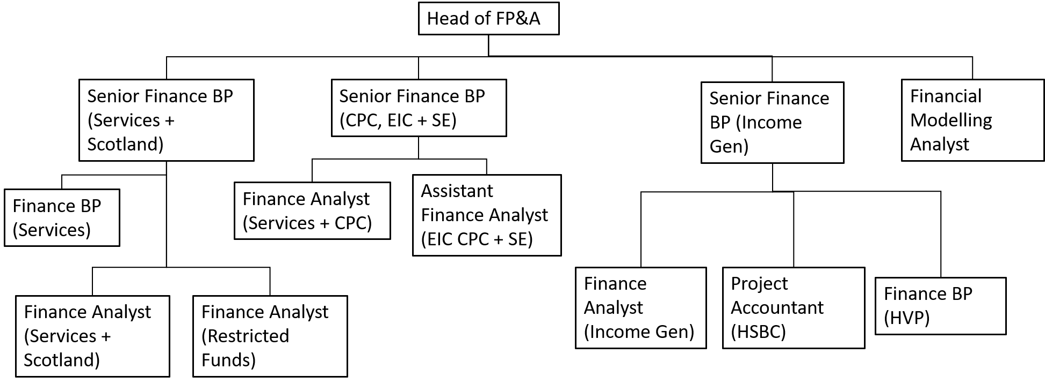

About the role

Key responsibilities and outcomes of the role are:

- Ensuring that management receive accurate reliable and timely information to enable decision making.
- Improved financial insight and analysis provided to organisational budget holders, which enables effective financial decision making and management of business performance by budget holders.
- Through training, education and ad hoc support, budget holders are empowered to engage effectively with financial planning (e.g. budgeting and forecasting).
- Supporting effective review of bids for and management of externally funded projects.

Role Specific Responsibilities

Review and insight of financials
- Reviewing monthly figures with a focus on areas of responsibilities to identify trends and variances. Review budget and forecast figures for reasonableness in line with understanding of area and drivers behind finances.
- Flag key issues in monthly figures and forecast/budget projections to other members of FP&A team and wider Finance team, as required. Flag issues with budget holders and follow up on required actions.
Empowering and Educating Budget Holders
- Building relationships with budget holders within area of responsibility, acting as first point of contact on queries regarding financial planning and analysis, and assisting them with ad hoc pieces of analysis where required.
- Contribute to design and delivery of training sessions for budget holders around the organisation to enable them to engage effectively with the FP&A cycle and understand their responsibilities as a budget holder regarding financial management.
Budgeting / Forecasting datamodel development
- Working with the Financial Modelling analyst, wider financial analysis team and budget holders to suggest improvement to data models based on the analyst’s understanding of their organisational area of responsibility, and helping the Financial Modelling analyst to test and implement amendments.
Development of Reports
- Proactively gathering budget holder feedback on potential improvements in management reporting, and under supervision, acting on feedback to incorporate budget holder requests into reports & data model, where appropriate.
- Using understanding of areas of the organisation that responsible for and drivers behind finances to proactively bring suggestions on new insights/ways of reporting to the organisation.
- Assisting with development and maintenance of user friendly and accurate management reporting and templates, and ensuring that these are published on a timely basis.
Month end processing
- Taking part in month end process, with a view to improvement and increasing efficiencies in month end processing.
- Maintain process notes and able to stand in / pick up work of other analysts as required due to capacity.
- Build strong relationships with other wider finance team members engaged in the month end process and understand their role in the process and how communication and/or month end tasks might be able to be streamlined or improved within the finance team as a whole.
Management of externally funded projects and review of bids for new work
- Prepare timely and accurate reports on restricted funded projects for submission to external funders, highlighting under/overspends to budget holders and highlighting and discussing options for managing under/overspends, where necessary.
- Play a key role in the review and challenge of proposed contract and grant business cases developed by business development or fundraising teams, reviewing from the perspective of both accuracy of costings and risks. Share any outstanding concerns following review with relevant Finance Business Partner for the area.
- Be prepared to engage with specific review groups within Directorate as required, for example on Restricted Income Panel as required to provide challenge/input on bids from a finance perspective.
- Maintain regular reporting for budget holders on restricted fund over/underspends, proactively work with budget holders and development teams to drive engagement with management of restricted funds and improve insights provided to organisation to inform fundraising decision making.
About you

- As well as being suitably qualified (as a full qualified or part qualified accountant) you’ll need to be used to working effectively with non-finance stakeholders and varying your communication style to suit the audience you’re addressing.
- You’ll also need excellent time management skills, including the ability to work to deadlines and reprioritise tasks when necessary.
- Excellent analytical skills, impeccable attention to detail, a high level of numeracy and intermediate Excel skills are all ‘must haves’ too, as is proficiency in the main Microsoft Office applications, including Outlook and Word.
- Previous experience in using accounting software (Unit 4 ERP and PowerBi) is also desirable but not required.
Required behaviours

The Shelter Behaviours demonstrate the attitudes and approaches we take to our work; from how we do things, how we treat each other and expect to be treated both internally and externally. They help us to have the culture we need to deliver our ambitious strategy.
At Shelter we have 5 overall behaviours, that are each made up of 3 descriptors, these are outlined below.
We work together to achieve our shared purpose
- by actively collaborating and putting trust in the people we work with
- by recognising the contribution of others
- by carefully considering the “how” when taking on new projects and initiatives

We prioritise diversity and have an inclusive and open mindset
- by not tolerating and actively tackling racism and any other forms of hate and discrimination
- by creating safe spaces for people to be their authentic self, challenge each other and learn
- by being compassionate towards the people we work with and prioritising each other’s wellbeing

We enable decision making
- by giving people the tools, they need to make well informed decisions
- by being accountable for the decisions we make
- by delegating authority to those closest to the work

We create change and align behind our strategy
- by participating in change initiatives that deliver our strategy
- by supporting tough strategic choices
- by saying no to work that does not serve our purpose

We are open to risk and learning from our experiences
- by learning from our failures and successes
- by being reflective and giving and receiving feedback
- by being proactive and taking initiative

Other information

- All staff should adhere to Shelter's Equality Policy and will be expected to play a key role in its successful implementation.
- This post is not exempt from the Rehabilitation of Offenders Act.

Please note
This job description cannot cover every issue or task that may arise within the post at various times and the post-holder will be expected to carry out other duties from time to time which are broadly consistent with those in this document. This job description does not form part of the contract of employment.

