

Job title: Content Editor
Location: Remote, can be officed based if preferred e.g. Sheffield, Manchester, London
Contract type: Fixed term contract – Ending December 2026
Accountable to: Senior Content Designer
Salary: Grade 3
Hours: 17.5 hours per week
Leave: 30 days holiday per annum plus bank holidays.
This is pro-rata for any employees working less than 35 hours per week

About Shelter

A home is a fundamental human need, as essential as education or healthcare. Yet millions of people across Britain struggle on a daily basis with homelessness, bad housing conditions, soaring rents, discrimination and the threat of eviction.

Above all we seek a transformation in housing policy, including investment in homes people on low incomes can actually afford – an investment that has been missing for decades and from all political parties, so that now the human cost has become intolerable.

We need ambitious, best-in-class individuals who are passionate about our cause to join us at this exciting time. This is your chance to play a part in the fundamental change we are striving to achieve.

Why Join Shelter?

We welcome anyone to apply who possess the qualities and behaviours outlined or who believes they have the propensity to learn them fast. You will be joining an inclusive and supportive team who welcome people from all backgrounds. What’s important isn’t your level of education or the opportunities which you have had, it’s about you and how you seize the opportunities ahead of you.

We are happy to talk about flexible working, personal growth, and to promote a workplace where you can be yourself and achieve success based only on your merit. We also offer the following benefits:

- Flexible working hours
- Flexible working practices
- 30 days paid holiday plus bank holidays
- Competitive pension scheme
- Salary sacrifice schemes

Diversity Statement

At Shelter we are united by our purpose to defend the right to a safe home; our enemy is the social injustice at the core of the escalating housing emergency. We believe to win that fight; we must be representative of the people we are here to help and those who support our movement for change. In all our people decisions, we take pride in being inclusive, fair, equitable and transparent.

We have committed to combat racism both within and outside Shelter and welcome you on our journey to becoming a truly anti-racist organisation.

About the team

The Digital Content Team plays a key role within Shelter by producing exciting content design work for directorates across the organisation. The content team delivers their work through the Digital team. Collectively, they set the example for Shelter in digital best practice, discovery and innovation. The Digital Content team creates compelling content that adheres to Shelter’s Content Strategy and achieves Shelter's Digital Purpose.

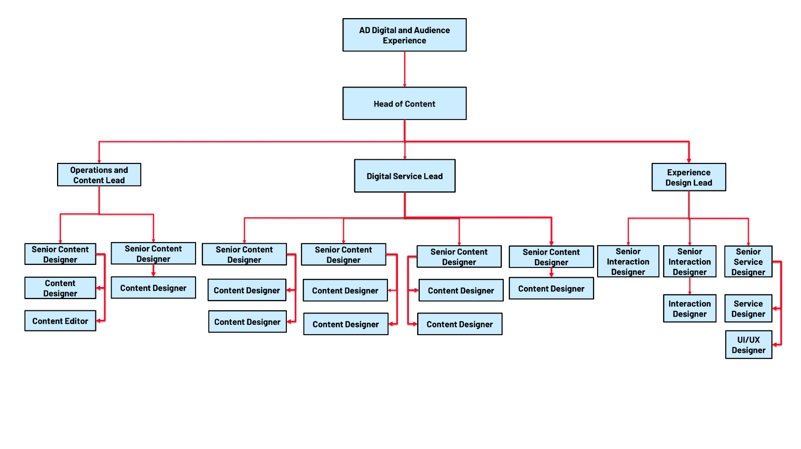

About Shelter’s Digital Purpose

Shelter’s Digital Purpose: Digital enables Shelter to meet its goals by creating engaging experiences which harness and amplify people power in the fight for home.

About the role

Reporting to the Senior Content Designer, the Content Editor role supports key elements of Shelter’s Content Strategy adoption, as well as acting as an ambassador for editorial excellence.

Role Specific Responsibilities

- Act as a guardian of house style and an editorial safety net for digital content ensuring that Shelter’s approach to content generation adheres to Content Strategy
- Contribute to the development of guidelines and standards for content in accordance with Shelter’s Content Strategy
- Participate in communities of practice and contribute to the development of guidelines and standards for content
- As well as writing and editing web, email, and blog content that engages, you’ll ensure Shelter’s web presence is high quality, user-centred, and relevant, with a consistent style and tone
- Work to a prioritised backlog in conjunction with Shelter’s Digital Product Managers
- Collaborate in regular sprint planning meetings, where work will be broken down and sorted into priority order
- Edit and feedback on web, email and blog content from across the organisation
- Maintain content on Shelter’s websites, ensuring it meets our high standards
- Collaborate with the content team on the redevelopment of Shelter’s house style guide and other editorial documentation

About you

- You will be an impeccable writer and editor with an excellent understanding of high-quality digital content
- You will be excellent at prioritising your workload and ensuring that Content is created that achieves Shelter’s Digital Purpose
- You will have excellent communication skills and have a strong ability to work with varied stakeholders from across Shelter
- You will have proven experience of writing and editing content, as well as a good understanding of digital editorial best practice
- You will know how to produce Tone of Voice guidelines, training, and style guide documentation
- You will understand search engine optimisation, web usability, and user-centred design
- You will be adept at critically analysing content using data and making and recommending necessary changes to others to enable incremental improvement
- You will be familiar with Content Management Systems

Required behaviours

The Shelter Behaviours demonstrate the attitudes and approaches we take to our work; from how we do things, how we treat each other and expect to be treated both internally and externally. They help us to have the culture we need to deliver our ambitious strategy.
At Shelter we have 5 overall behaviours, that are each made up of 3 descriptors, these are outlined below.
We work together to achieve our shared purpose
- by actively collaborating and putting trust in the people we work with
- by recognising the contribution of others
- by carefully considering the “how” when taking on new projects and initiatives

We prioritise diversity and have an inclusive and open mindset
- by not tolerating and actively tackling racism and any other forms of hate and discrimination
- by creating safe spaces for people to be their authentic self, challenge each other and learn
- by being compassionate towards the people we work with and prioritising each other’s wellbeing

We enable decision making
- by giving people the tools, they need to make well informed decisions
- by being accountable for the decisions we make
- by delegating authority to those closest to the work

We create change and align behind our strategy
- by participating in change initiatives that deliver our strategy
- by supporting tough strategic choices
- by saying no to work that does not serve our purpose

We are open to risk and learning from our experiences
- by learning from our failures and successes
- by being reflective and giving and receiving feedback
- by being proactive and taking initiative

Other information

- All staff should adhere to Shelter's Equality Policy and will be expected to play a key role in its successful implementation
- This post is not exempt from the Rehabilitation of Offenders Act

Please note:

This job description cannot cover every issue or task that may arise within the post at various times and the post-holder will be expected to carry out other duties from time to time which are broadly consistent with those in this document. This job description does not form part of the contract of employment.

