

Job Title: Interaction Designer
Location: London or Remote (UK)
Contract type: Fixed term contract – ends June 2027
Accountable to: Senior Interaction Designer
Salary: Shelter Grade 4
Hours: 37.5per week (pro-rata if part time)
Leave: 30 days holiday per annum plus bank holidays

About Shelter

A home is a fundamental human need, as essential as education or healthcare. Yet millions of people across Britain struggle with homelessness, bad housing conditions, soaring rents, discrimination, and the threat of eviction. We are striving for change, with individuals, in communities and across society.

Above all we seek a transformation in housing policy, including investment in homes people on low incomes can afford – an investment that has been missing for decades and from all political parties, so that now the human cost has become intolerable.

We are looking for ambitious individuals who are passionate about our cause. This is a great time to join us as we strive to achieve fundamental change.

Why Join Shelter?

We welcome anyone to apply who possess the qualities and behaviours outlined or who believes they have the propensity to learn them fast. You will be joining an inclusive and supportive team who welcome people from all backgrounds. What’s important isn’t your level of education or the opportunities which you have had, it’s about you and how you seize the opportunities ahead of you.

We are happy to talk about flexible working and opportunities for professional development. We offer a diverse and inclusive workplace in which you can thrive and be yourself. We also offer the following benefits:

- Flexible working hours
- Flexible working practices
- 30 days paid holiday plus bank holidays
- Competitive pension scheme
- Salary sacrifice schemes
- enhanced family friendly policies
- interest free travel loans
- tenancy deposit loan
- cycle to work scheme
- an employee assistance programme.

Diversity Statement

At Shelter, we are united by our purpose to defend the right to a safe home. Our enemy is the social injustice at the core of the escalating housing emergency. To win that fight, we must be representative of the people we are here to help and those who support our movement for change.
We take pride in being inclusive, equitable and transparent in everything we do. We have committed to combat racism both within and outside Shelter. We welcome you on our journey to becoming a truly anti-racist organisation.

About the team
The Design team plays a key role within Shelter by producing engaging user experiences for advice services, campaigns, fundraising and cross cutting journeys. We are user centred design leaders that collaborate across the organisation to develop digital solutions that meet user needs and organisational goals. Disciplines in the team include Service Design and Interaction Design. They work closely with other teams – particularly the Content team, Product and Delivery team, Insight and BI team and business owners in Services and Income Generation. Collectively, they set the example for Shelter in digital best practice, discovery and innovation.

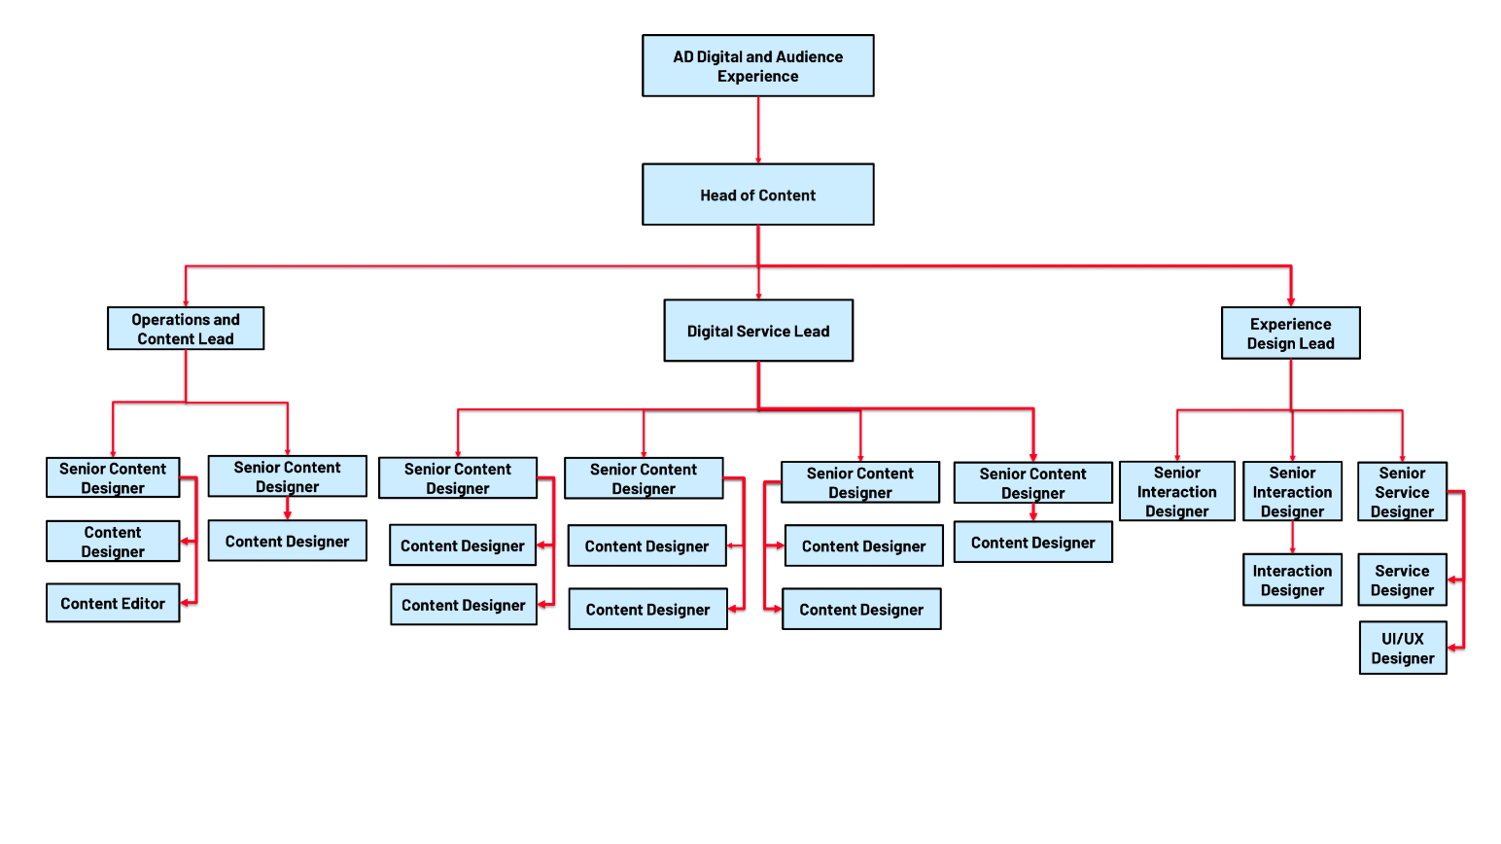

About Shelter’s Digital Purpose

Shelter’s Digital Purpose: Digital enables Shelter to meet its goals by creating engaging experiences which harness and amplify people power in the fight for home.
About the role
This role is part of the Design team and reports to the Senior Interaction Designer. The role will work closely with product managers and product teams that are aligned with Shelter’s Strategic Priorities.

As an Interaction Designer, you will work out the best ways to enable users to engage and interact with Shelter, your responsibilities will cover:

- Inclusive Design - You understand that people interact with products differently based on their abilities, contexts, and lived experiences. You design solutions that are usable, accessible, and equitable. Supporting product teams to understand the impact of their decisions on accessibility, digital exclusion and user journeys.
- Evidence led design – You use qualitative and quantitative data to inform develop and test a design hypothesis. You can analyse, synthesis and clearly explain evidence relevant to a user experience.
- Iterative design - You can apply iterative design principles and agile methodologies to your work. You are confident prototyping new ideas at different fidelities, ready to test and iterate with users. Using a range of design tools and techniques. You can iterate on existing design patterns and components in Shelter Design System.
- Designing at scale - You contribute to the development of Shelter's Design System by creating, documenting, and maintaining reusable components and patterns that align with established UI patterns, accessibility standards and brand guidelines. Collaborate with developers and other designers to ensure accurate implementation, consistency and scalability across products. You ensure that designs meet appropriate standards, such as accessibility guidelines, and go beyond compliance to actively remove barriers and create fair, inclusive experiences for all users.
- Design communication - You can clearly explain problems, ideas and design decisions to others. Helping teams to align design intent, build a shared understanding and maintain momentum towards a common goal.
- Design collaboration - You can effectively plan and run design sessions with a group.
- You meaningfully involve the right people throughout the design process.
- Leading design - you actively demonstrate the value of user-centred design with teams not familiar through facilitation and sharing skills and knowledge. You build confidence and help to embed UCD practices, the digital purpose and the content strategy.

About you

We're looking for someone who has experience:

- Designing inclusive and accessible digital products and services
- Testing design hypotheses, gathering feedback and translating research insights into actionable design decisions
- Using and developing new design components and patterns that meet user needs, accessible standards and create engaging user experiences.
- Preparing design assets, ensuring components, interactions and behaviours are clearly documented. Collaborating closely to clarify intent, support implementation and maintain design consistency.
- Generating ideas and facilitating workshops or co-design activities.
- Prototyping or wireframing solutions at the appropriate fidelity. We use Miro and Figma.
- Working collaboratively, listening to and acting on feedback and communicating effectively.
- Applying user-centred design principles in multi-disciplinary teams.

Required behaviours

The Shelter Behaviours demonstrate the attitudes and approaches we take to our work; from how we do things, how we treat each other and expect to be treated both internally and externally. They help us to have the culture we need to deliver our ambitious strategy.
At Shelter we have 5 overall behaviours, that are each made up of 3 descriptors, these are outlined below.
We work together to achieve our shared purpose
- by actively collaborating and putting trust in the people we work with
- by recognising the contribution of others
- by carefully considering the “how” when taking on new projects and initiatives

We prioritise diversity and have an inclusive and open mindset
- by not tolerating and actively tackling racism and any other forms of hate and discrimination
- by creating safe spaces for people to be their authentic self, challenge each other and learn
- by being compassionate towards the people we work with and prioritising each other’s wellbeing

We enable decision making
- by giving people the tools, they need to make well informed decisions
- by being accountable for the decisions we make
- by delegating authority to those closest to the work

We create change and align behind our strategy
- by participating in change initiatives that deliver our strategy
- by supporting tough strategic choices
- by saying no to work that does not serve our purpose

We are open to risk and learning from our experiences
- by learning from our failures and successes
- by being reflective and giving and receiving feedback
- by being proactive and taking initiative

Other information
- All staff should adhere to Shelter's Equality Policy and will be expected to play a key role in its successful implementation
- This post is not exempt from the Rehabilitation of Offenders Act

Please note:

This job description cannot cover every issue or task that may arise within the post at various times and the post-holder will be expected to carry out other duties from time to time which are broadly consistent with those in this document. This job description does not form part of the contract of employment.

