Job Description
Job Title: Audience Research and Insight Manager
Location: Remote, Sheffield, Manchester, Bristol, London
Contract type: Permanent
Accountable to: Head of Strategic Evaluation and Insight
Salary: Grade 6.2
Hours: 35 per week
Leave: 30 days holiday per annum plus bank holidays

About Shelter
A home is a fundamental human need, as essential as education or healthcare. Yet millions of people across Britain struggle on a daily basis with homelessness, bad housing conditions, soaring rents, discrimination and the threat of eviction.

Above all we seek a transformation in housing policy, including investment in homes people on low incomes can actually afford – an investment that has been missing for decades and from all political parties, so that now the human cost has become intolerable.

We need ambitious, best-in-class individuals who are passionate about our cause to join us at this exciting time. This is your chance to play a part in the fundamental change we are striving to achieve.

Why Join Shelter?
We welcome anyone to apply who possess the qualities and behaviours outlined or who believes they have the propensity to learn them fast. You will be joining an inclusive and supportive team who welcome people from all backgrounds. What’s important isn’t your level of education or the opportunities which you have had, it’s about you and how you seize the opportunities ahead of you.

We are happy to talk about flexible working, personal growth, and to promote a workplace where you can be yourself and achieve success based only on your merit. We also offer the following benefits:
- Flexible working hours
- Flexible working practices
- 30 days paid holiday plus bank holidays
- Competitive pension scheme
- Salary sacrifice schemes

In terms of flexibility, we are happy to receive applications from people interested in hybrid (office/home based) working. We do also offer the possibility of working exclusively within the office if this is what applicants are seeking. Any hybrid working would probably involve coming into our offices one or two days a week depending on business demand. We are also willing to consider part time applicants where we can offer a four-day working week, if needed.

Diversity Statement
At Shelter we are united by our purpose to defend the right to a safe home; our enemy is the social injustice at the core of the escalating housing emergency. We believe to win that fight; we must be representative of the people we are here to help and those who support our movement for change. In all our people decisions, we take pride in being inclusive, fair, equitable and transparent.

We have committed to combat racism both within and outside Shelter and welcome you on our journey to becoming a truly anti-racist organisation.

About the team
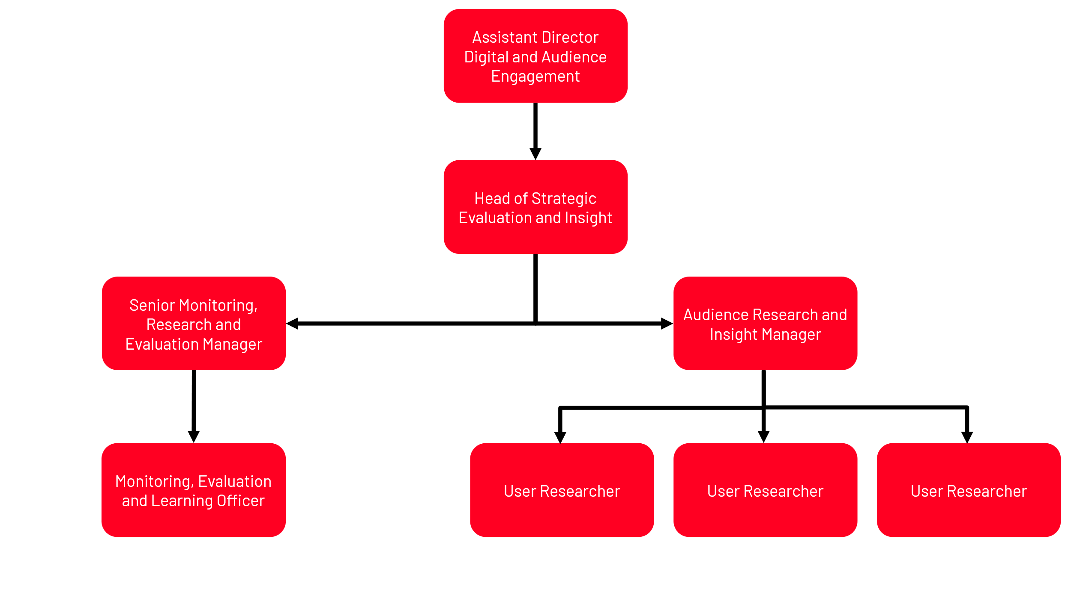

This role sits in the 7-person Strategic Evaluation and Insight team which sits in the Digital and Audience Engagement sub directorate, within the Campaigns, Policy and Communications (CPC) department.

The team is a keystone in shaping and delivering the work of Shelter bringing together Strategic Monitoring, Evaluation and Learning, Audience insight and User Research.

The team has a primary mandate to deliver a full range of integrated strategic support across Shelter to ensure the delivery of coherent, high quality, highly strategic public engagement approaches. It’s a central point in ensuring that all work to deliver Shelter’s strategy is planned using best practice principles of programme design, monitoring, evaluation and learning and is underpinned by user research and audience insight.

Within the Strategic Evaluation and Insight team, the Audience Research and Insight function advocates for and demonstrates the value of being audience centred and insight led in our digital discovery and design, and project and campaign development. The research and insight the team generates allows Shelter to create engaging experiences which harness and amplify peoplepower in the fight for home.

About the role

The role of Audience Research and Insight Manager is a vital role, working with teams across Shelter to develop valuable insights into our key and varied audiences, ensuring user needs are valued along with the needs of the organisation, and our work is underpinned by actionable insight. Our audiences include donors (regular givers, occasional donors, eventers, community fundraisers), retail audiences (online and high street shoppers and donors), campaigners, service users, volunteers and elite audiences (journalists, politicians, policy makers, housing professionals) and corporate partners. These insights ensure that our work is audience focussed, targeted effectively and uses the latest techniques to understand user needs, our audiences’ underlying beliefs and attitudes that drive behaviours. The main objectives of the role are to:

- Continue to develop and deliver Shelter’s audience research and insight strategy in line with our strategic priorities.
- Develop a programme of audience research and insight into Shelter’s audiences across change, services, awareness and fundraising campaigns, managing the User Researcher’s to deliver this programme as well as delivering project yourself.
- Work with teams generating insight across Shelter to develop and manage an insight sharing programme to keep the organisation up to date on insights and make it easy for them to access the evidence they need to make decisions.
- Champion the strategic importance of insight across Shelter teams and embed an insight-led approach to all our communications internally and externally through skill sharing and disseminating findings.

What you add:

You’re a confident communicator and manager, able to work effectively with colleagues across teams and influence a wide range of roles including senior management. Acting as a cross-departmental resource, you will need to use these influencing skills to build strong relationships across teams to champion audience centered design, identify insight needs and help turn them into action.

You will also have strong project management skills, able to identify insight gaps, scope and design research projects to meet those needs, deliver and disseminate research and support teams in actioning recommendations. At times you will need to manage a variety of complex projects at the same time, and manage external research agencies, ensuring Shelter gets the best service, price and actionable insight from commissioned work.

Role Specific Responsibilities

Specific responsibilities of this role include:
- Line management of User Researchers and championing of user centred design and inclusive research.
- Analysing and interpreting primary and secondary research, analysing client and supporter data, quantitative and qualitative data, delivering audience insights and putting forward recommendations for action.
- Building a picture of Shetler’s audiences shaped by evidence from a wide range of data sources, including primary research, data analytics and web analytics.
- Developing audience analysis that allows teams to select the most appropriate audiences, propositions and communication channels.
- Drive forward an insight led, audience focussed culture, acting as internal consultant in meetings and forums and working with colleagues to provide better access to existing insights to inform decision making.
- Work closely with the other functions within the team and outside to provide and interpret brand and impact tracking data for internal reporting and decision making.
- Network externally to understand how audience research and insight is used across other organisations and utilise new techniques for insight development.
- Keep up to date with and share relevant market insights to build a picture of the external context that we are operating in, i.e. the charity sector, economic and political situation, etc.

About you

You will have:

Essential criteria
- Experience in market / consumer / user research and insight including both qualitative and quantitative primary research techniques.
- Strong project management experience and organisational skills.
- Analytical thinking and creative problem solving, including experience of developing propositions for testing.
- Ability to draw conclusions from data and communicating clearly as an internal consultant.
- People management achieved either through formal line management or informal stakeholder management.
- Strong written and verbal communication skills.
- An understanding of user-centred research and design principles and digital design methods such as agile, lean or scrum working.
- An interest in and/or knowledge of housing and homelessness or related social policy issues.

Desirable criteria

- Experience of using geo-demographic audience data sources such as ACORN and MOSAIC and / or experience in using data analysis packages such as SPSS.
- Experience of using CRM data to draw out insights and inform decision making.
- Knowledge of inclusive research design approaches.
- An interest in how AI can support research approaches to create efficiencies in processes.

Required behaviours

The Shelter Behaviours demonstrate the attitudes and approaches we take to our work; from how we do things, how we treat each other and expect to be treated both internally and externally. They help us to have the culture we need to deliver our ambitious strategy.
At Shelter we have 5 overall behaviours, that are each made up of 3 descriptors, these are outlined below.
We work together to achieve our shared purpose
- by actively collaborating and putting trust in the people we work with
- by recognising the contribution of others
- by carefully considering the “how” when taking on new projects and initiatives

We prioritise diversity and have an inclusive and open mindset
- by not tolerating and actively tackling racism and any other forms of hate and discrimination
- by creating safe spaces for people to be their authentic self, challenge each other and learn
- by being compassionate towards the people we work with and prioritising each other’s wellbeing

We enable decision making
- by giving people the tools, they need to make well informed decisions
- by being accountable for the decisions we make
- by delegating authority to those closest to the work

We create change and align behind our strategy
- by participating in change initiatives that deliver our strategy
- by supporting tough strategic choices
- by saying no to work that does not serve our purpose

We are open to risk and learning from our experiences
- by learning from our failures and successes
- by being reflective and giving and receiving feedback
- by being proactive and taking initiative

Other information
- All staff should adhere to Shelter's Equality Policy and will be expected to play a key role in its successful implementation.
- This post is not exempt from the Rehabilitation of Offenders Act.

Please note
This job description cannot cover every issue or task that may arise within the post at various times and the post-holder will be expected to carry out other duties from time to time which are broadly consistent with those in this document. This job description does not form part of the contract of employment.

